# Laboratory 4

Title of the Laboratory Exercise: implement constraints and built in functions

1. Introduction and Purpose of Experiment

Constraints are the rules which are enforced on the data being stored in a table. There are constraints that can be applied to a table such as NOT NULL, UNIQUE, PRIMARY KEY and FOREIGN KEY. SQL has many built-in functions for performing calculations on data. In SQL, a built-in function is a piece for programming that takes zero or more inputs and returns a value. By doing this lab, students will be able to implement constraints and built in functions on the database.

1. Aim and Objectives

Aim

* To design and implement constraints on the data using SQL commands
* To implement built in functions in SQL

Objectives

At the end of this lab, the student will be able to

* Identify different types of constraints on the data
* Apply constraints on the data in different ways
* Implement built-in functions in SQL

1. Experimental Procedure
   * 1. Analyse the problem statement
     2. Design SQL commands using appropriate constraints
     3. Execute the SQL commands
     4. Test the executed commands
     5. Document the Results
     6. Analyse and discuss the outcomes of your experiment
2. Questions

Consider the relational schema given below.

PLAYER_DETAILS (PCode, PName, DOB, City, Score)

MATCH_DETAILS (MatchID, MatchName, PCode)

a

1. Apply the following constraints on the given database schema. Enter appropriate tuples to show the purpose of each constraint.
2. Not NULL
3. Default
4. Unique
5. Primary key
6. Foreign key
7. Execute the following built-in functions in SQL using NetBeans IDE
8. String functions
9. Date functions
10. Numeric functions
11. Presentation of Results

**Creating tables for the given problem statement**

**1. Player Details**

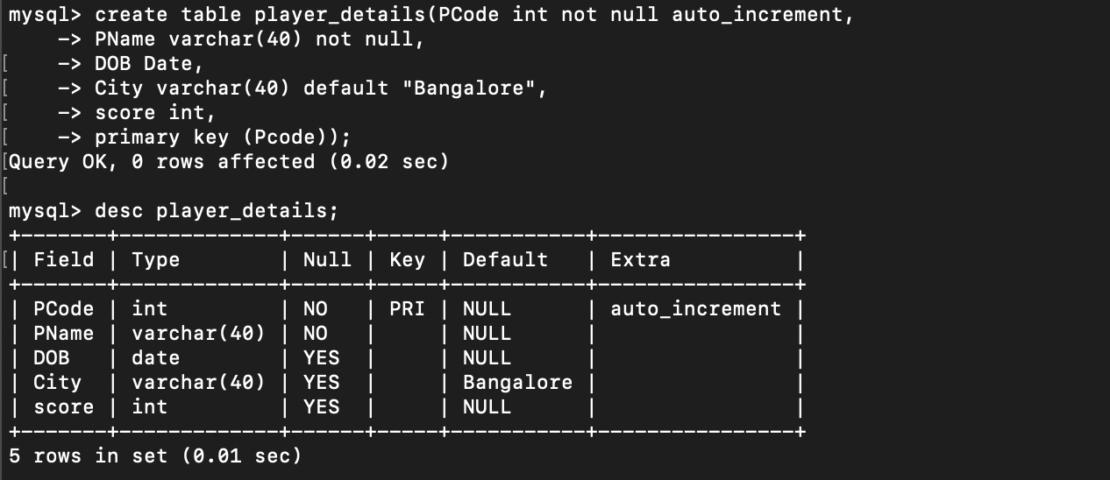

Figure 1 MySQL Query to Create a table "Player Details" and Describing the table.

**2. Match Details**

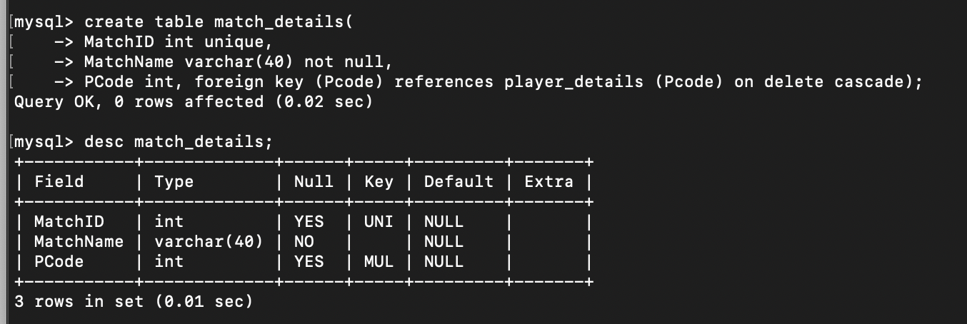

Figure 2 MySQL Query to Create a table "Match Details" and Describing the table.

**a. Not NULL**



Figure MySQL Constraint Error for "Not Null"

 **b. Default**

Figure 4 MySQL Query for Inserting data into table with default column

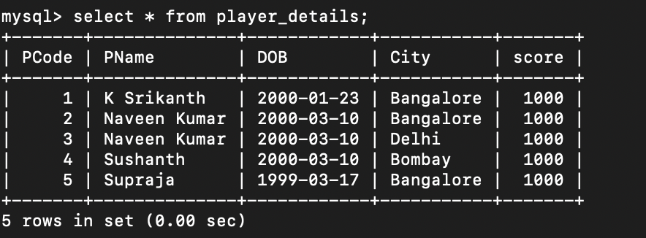

Figure 5 MySQL Query to print the table "Players details" and showing an default value from the query figure 4

**c. Unique**



Figure 6 MySQL Constraint Error for "Unique"

**d. Primary key**

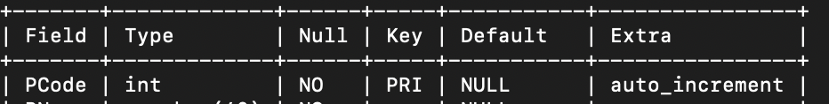

Figure 7 MySQL Table displaying "PCode" as a primary Key.

** e. Foreign key**

Figure 8 MySQL Constraint Error for "Foreign Key"

**b. Execute the following built-in functions in SQL using NetBeans IDE but I used VS Code.**

**Making a connection on VS Code**

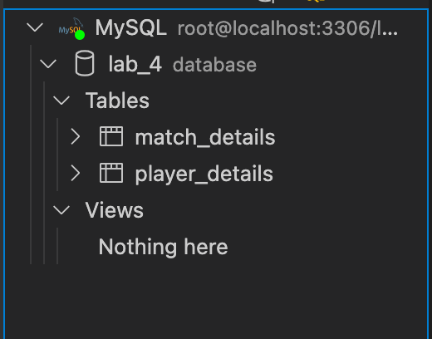

Figure 9 Making a MySQL Server Connection on VS Code Editor and connecting to database “lab_4”

1. **String functions**

* **Upper ()**

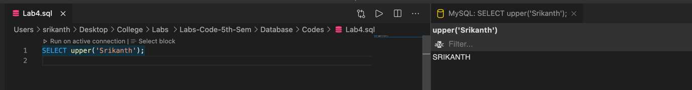

Figure 10 MySQL Query using Upper() inbuilt function.

* **Lower ()**

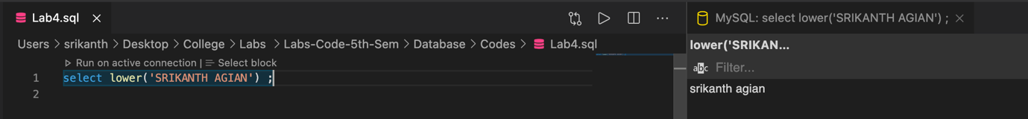

Figure 11 MySQL Query using Lower() inbuilt function

* **Concat ()**

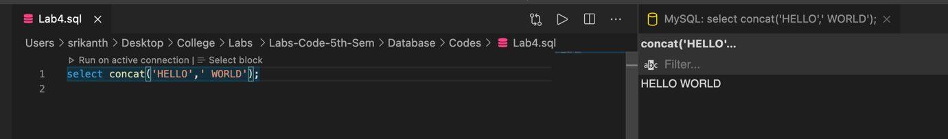

Figure 12 MySQL Query using Concat() inbuilt function

* **Replace ()**

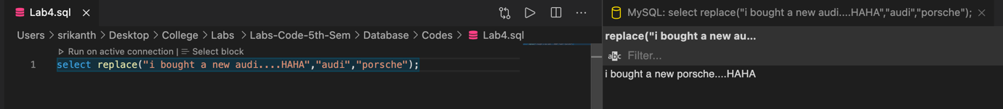

Figure 13 MySQL Query using Replace() inbuilt function

* **Length ()**

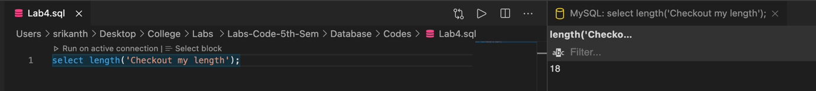

Figure 14 MySQL Query using Length() inbuilt function

1. **Date functions**

* **Sysdate ()**

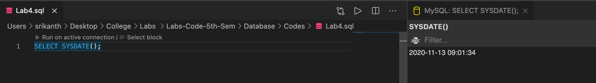

Figure 15 MySQL Query using Sysdate () inbuilt function

* **Curtime ()**

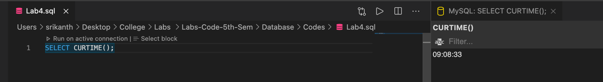

Figure 16 MySQL Query using Curtime() inbuilt function

* 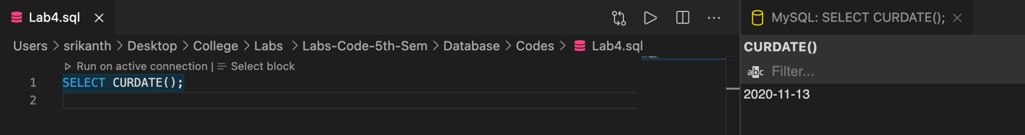**Curdate ()**

Figure 17 MySQL Query using Curdate () inbuilt function

1. **Numeric functions**

* 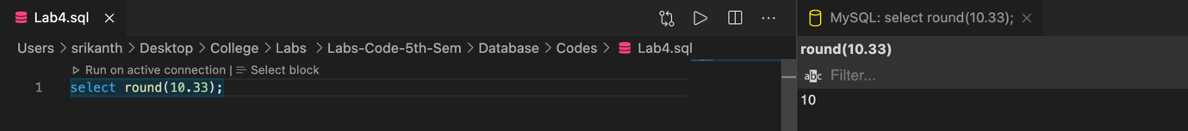**Round ()**

Figure 18 MySQL Query using Round () inbuilt function

* **Ceil ()**

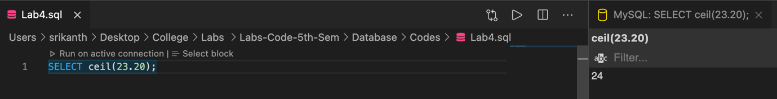

Figure 19MySQL Query using Ceil () inbuilt function

* **Floor ()**

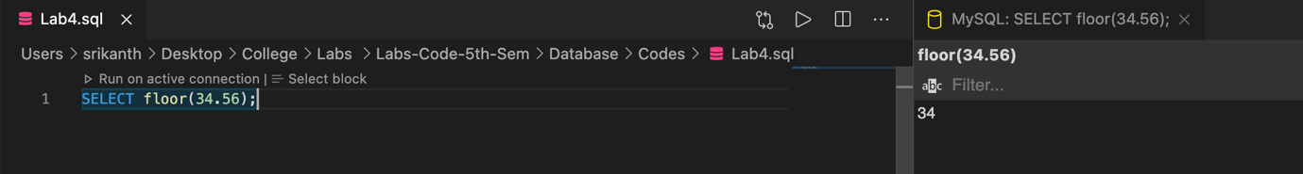

Figure 20 MySQL Query using Floor () inbuilt function

* **Sign ()**

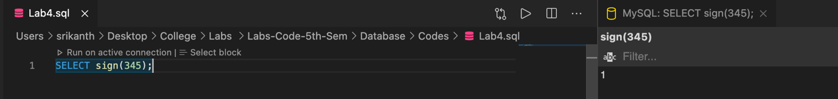

Figure MySQL Query using Sign () inbuilt function

**Math Functions**

* **Abs ()**

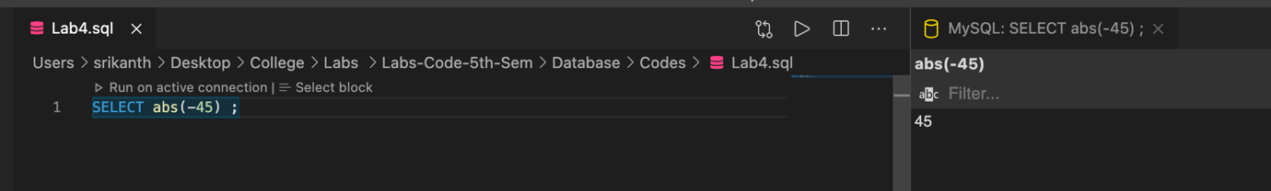

Figure 22 MySQL Query using abs () inbuilt function

* **Power ()**

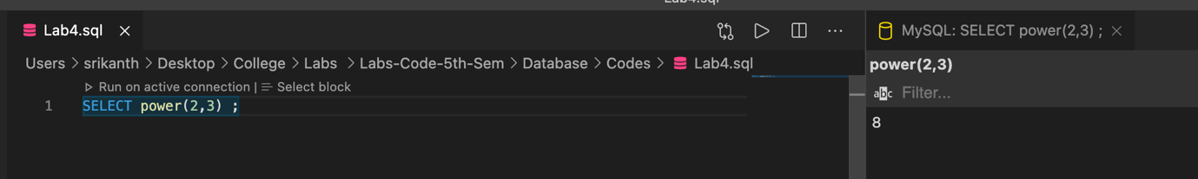

Figure 23 MySQL Query using Power () inbuilt function

* **Mod ()**

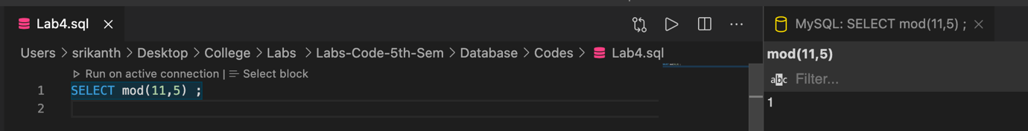

Figure 24 MySQL Query using Mod () inbuilt function

* **Sqrt ()**

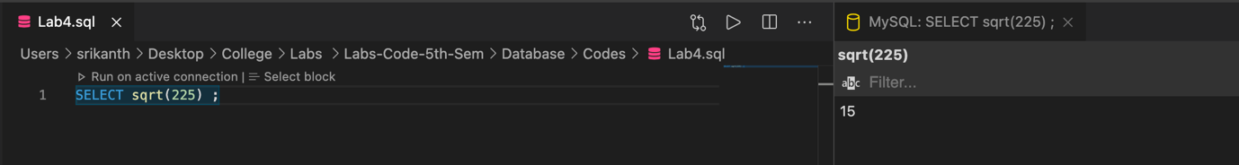

Figure 25 Figure 25 MySQL Query using Mod () inbuilt function

1. **Analysis and Discussions**

**Sub Question – A**

1. **Not NULL**

This is a constraint used when a data field is required to have a data and can’t be empty

**Reference Image : Image 3**

1. **Default**

This is a constraint used when we have a default value while creating a table so when the user doesn’t insert any value into this particular column then it will consider the default value from when we create the table

**Reference Image : Image 4 and Image 5**

1. **Unique**

This is a constraint used when the data has to be unique and also when we don’t want any duplicity of the data in our table.

**Reference Image : Image 6**

1. **Primary key**

This is key constraint used to define a key for an entire data set of a row in a table because when the data has to called in other table for a reference then it can be called using this key

**Reference Image : Image 7**

1. **Foreign key**

This is key constraint used to define a key that was a primary key from table 1 and wants to be used in a table 2 so the primary key from table 1 acts a foreign key in table 2 but if the key doesn’t exist then it will give you an error

**Reference Image : Image 8**

**Sub Question – B**

1. **String functions**

* **Upper ()**

This is a inbuilt function used to change all the lowercase letters to uppercase letters .

**Reference Image : Image 10**

* **Lower ()**

This is a inbuilt function used to change all the uppercase letters to lowercase letters .

**Reference Image : Image 11**

* **Concat ()**

This is a inbuilt function used to concatenate strings.

**Reference Image : Image 12**

* **Replace ()**

This is a inbuilt function used to replace strings and this function takes three arguments firstly the string followed by the string for changing and the string that its being changing to .

**Reference Image : Image 13**

* **Length ()**

This is a inbuilt function is used to find the length of a string.

**Reference Image : Image 14**

1. **Date functions**

* **Sysdate ()**

This is a inbuilt function which returns the system date in format YYYY/MM/DD along with time in format H/M/S/MS

**Reference Image : Image 15**

* **Curtime ()**

This is a inbuilt function which returns the system current time in format H/M/S/MS

**Reference Image : Image 16**

* **Curdate ()**

This is a inbuilt function which returns the system current date in format YYYY/MM/DD

**Reference Image : Image 17**

**c. Numeric functions**

* **Round ()**

This is a inbuilt function which returns the rounded value of float or double .

**Reference Image : Image 18**

* **Ceil ()**

This is a inbuilt function which returns the ceiling value of a number.

**Reference Image : Image 19**

* **Floor ()**

This is a inbuilt function which returns the Floor value of a number.

**Reference Image : Image 20**

* **Sign ()**

This is a inbuilt function which returns the sign of the number if the number is positive then it will returns “1” and if it’s not then “-1”

**Reference Image : Image 21**

**Math Functions**

* **Abs ()**

This is a inbuilt function which returns the absolute value of a number.

**Reference Image : Image 22**

* **Power ()**

This is ainbuilt function which returns the power of integer and this function takes two arguments one is the base followed by power

**Reference Image : Image 23**

* **Mod ()**

This is ainbuilt function which returns the remainder of a number divided by another number this takes two arguments firstly the value which is going to be divided by the divisor and secondly the divisor

**Reference Image : Image 24**

* **Sqrt ()**

This is ainbuilt function which returns the square root of a integer.

**Reference Image : Image 25**

1. **Conclusions**

In a relational database, digital information is organized into rows, columns and tables which are  indexed to make it easier to find relevant information through SQL. Constraints are specified to limit  the data in the tables. In-built functions provide extended set of operations on data.

1. **Comments**

**Learning happened**

* + To design and implement constraints on the data using SQL commands
  + To implement built in functions in SQL.